Notes & News

### Mrs. Shockley’s

1st Grade Class

# 2nd Quarter & Serious About Success

|  |
| --- |
| Hello Again! |
| Kids of Character |
| Dates to Highlight |
|  |
| Forging Friendships |
| Memories Made |
| How You Can Help |

It’s easy to find reasons to applaud the terrific students in our class. At last month’s Citizens & Scholars Assembly we recognized students who had demonstrated October’s trait, LEADERS [Doing the right thing, even when no one is looking. Empowering and supporting others. Constantly finding ways to improve oneself. Maintaining a positive attitude and a sense of humor.] – Charlie C. and Eloise L. For November, our focus is on being RECEPTIVE & REFLECTIVE TO FEEDBACK [Valuing feedback to help oneself improve and further develop skills to achieve personal growth.

Reflecting critically about past experiences to inform future progress. Being aware of individual strategies, feelings, actions, and how these affect others.]. I look forward to having a difficult time selecting students to represent us because we’re all so committed to making great choices at school.

## Celebrating Our Citizen Scholars

Inside this issue:

The nights are chilly, the leaves are dropping, and your children are growing by leaps and bounds. This must mean that fall is well underway and our first quarter is now behind us!

I’ve enjoyed getting to meet with so many of you over the past couple of weeks for our fall parent-teacher conferences. It was great to spend time with you face-to-face and have the opportunity to share how remarkable your individual children are. Thank you for your commitment to working together to ensure that all our children have a successful year. Fall quarter report cards will be sent home on Wednesday. They are yours to keep. Please sign and comment on the enclosed parent signature card and return it in the report card envelope as soon as possible.

Our first grade days are academically full! Literacy has been focused building a reading life. Our math studies have included adding and subtracting within 20. In science we’re finishing our study of force and motion and. Social studies attention will be about participating in the democratic process, honoring our veterans, and current events.

Read on for more updates from Room B-19!

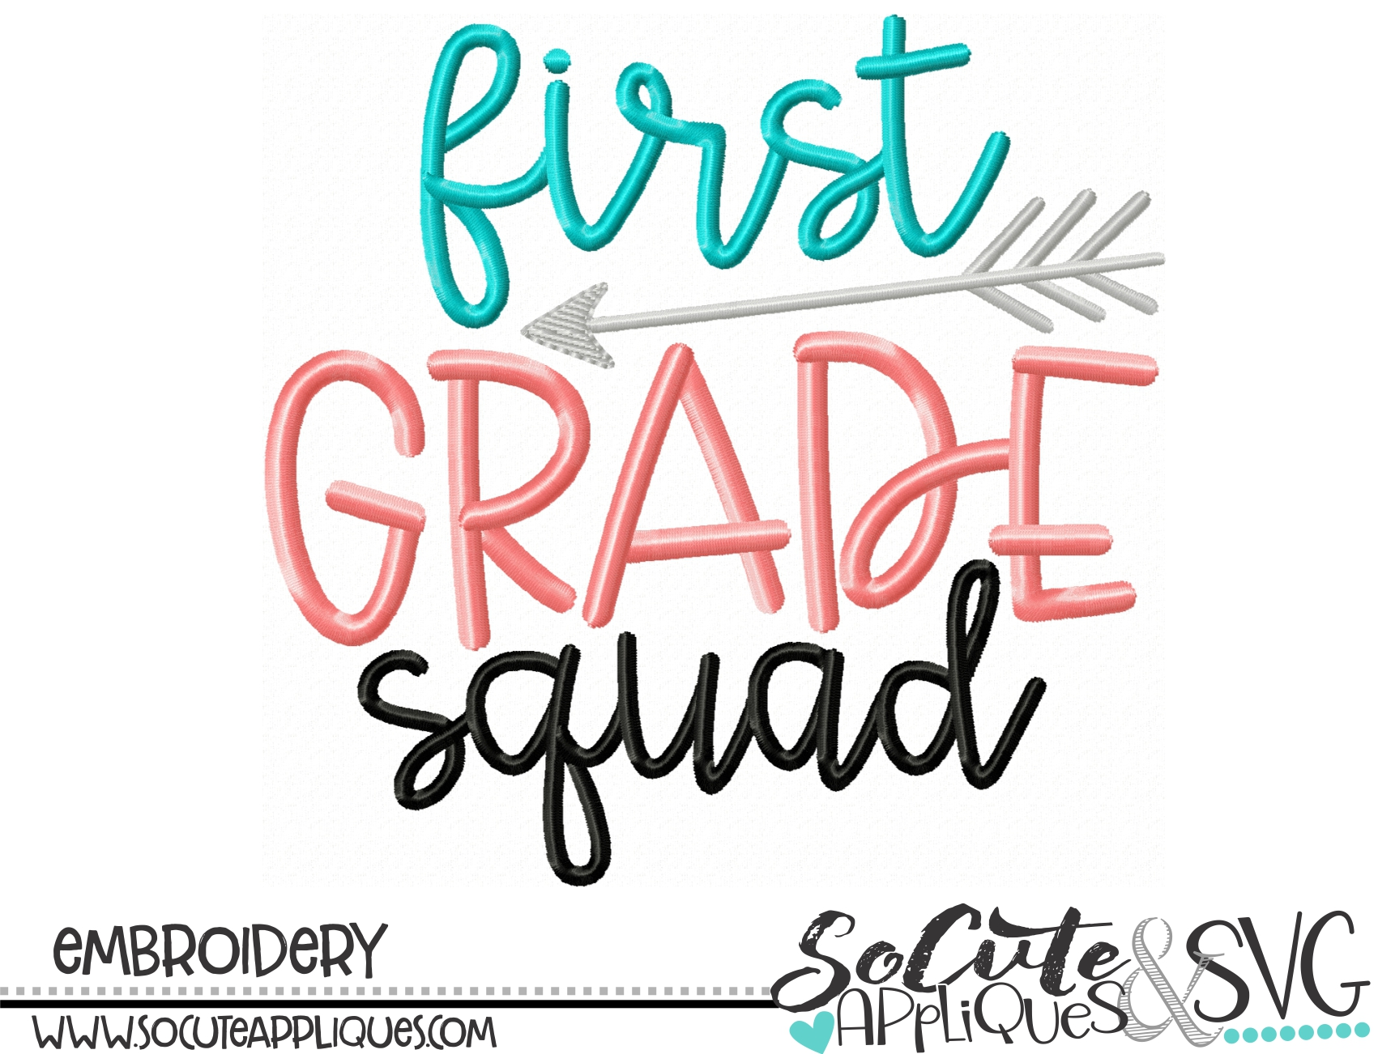

Monday,

November 4, 2019

Mark Your Calendar

* **TUES 11/5** Election Day / Teacher Workday
* **WED 11/6** Report Cards Distributed
* **THU 11/7** First Grade Field Trip to Discovery Place
* **MON 11/12** Veterans’ Day Holiday
* **MON 11/18-FRI 11/22** First Grade Service Project -Loaves & Fishes Food Drive
* **WED 11/20** Fall Picture Retakes
* **FRI 11/22** Citizens & Scholars Assembly
* **WED 11/27 – SUN 12/1** Thanksgiving Break

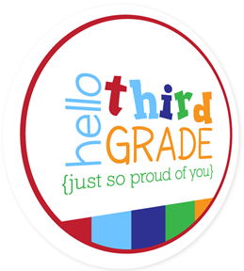

Now that we have our first quarter behind us, we are realizing that a number of us have become just a bit too comfortable with one another. We have begun to struggle to show our best selves to one another

For years I have subscribed to the Responsive Classroom belief that how children learn to treat one another is as important as what they learn in reading, writing, and arithmetic. I believe that social skills such as cooperation, responsibility, empathy, and self-control are essential to children’s academic and social success. We spend time in class reading, learning, and talking about this each and every day.

I am asking for your help from home. Please regularly ask your child questions like:

* How were you a friend today?
* Whose bucket did you fill today?
* Who do you not know very well? What can you do to become that person’s friend?
* What did you notice about your classmates today that you could give compliments for?
* Who have you not complimented during our morning meetings? How could you fill that classmate’s bucket with your kindness?
* Do your choices help you and others learn in class? Do they help to earn your class compliments in specials or when moving around the school?

Children getting to bed on time, eating a hearty breakfast, getting to class (not the front of the school!) no later than 7:40, and having school and personal materials packed makes for a great start to the day. At the end of the day, here are our class homework expectations:

**READING** –Minimum requirement of 20 minutes of reading daily. Book & minutes read should be recorded each day.

**MATH** –Daily math sheets are sent home on Friday and are due by the following Friday. Adults should be checking this work and recording the check on the back.

**CHOICE ACTIVITIES** – These are found on the back of the HW card. Keep in mind that parents are invited to create their own choices that work best for your family situation. For instance: Set the table, teach a sibling to build a tower, take the dog for a walk. Just note this on the HW card.

**SIGHT WORD PRACTICE** – Listed on the HW card. Practice these in the way that works best for your child’s learning style and your family’s schedules.

“The great aim of education is not knowledge but action.”

**- Herbert Spencer (English philosopher, biologist, anthropologist, sociologist)**

We are determined to regularly inject fun into our learning this year. One recent opportunity we enjoyed was sharing our book character costumes and celebrating our All Hallows Read.

Your children are lovers of stories. I see that each time I open a book to read aloud to them and as they clamor to get time to read independently. The stories we share provide us with chances to construct common meanings and memories with one another.

We will continue to build relationships and memories with each other as we learn and explore together. Big events for us over the next month include our Discovery Place field trip, our first grade service project – the Loaves & Fishes Food Drive, and beginning our Family Traditions Projects. Be on the lookout for more information about each of these and other community building learning experiences soon!

## How Can You Help (Homework, Organization, Etc.)

## Making Memories That Are Meaningful

## Using Character to Make Connections