Notes & News

### Mrs. Shockley’s

1st Grade Class

# Ho Ho Holiday Gift Giving Ideas

## We’re All Working to Stay on the Nice List ☺

Monday,

December 2, 2019

Inside this issue:

|  |
| --- |
|  |
| Santa’s Helper |
| Character Kids |
| Dates of Note |
|  |
| Brains on Break |
| One Last Thing |

While I wholeheartedly agree with Dr. Seuss, “Christmas doesn’t come from a store, maybe Christmas perhaps means a little bit more,” I do love the opportunity to give gifts that delight hearts and have a long lasting impact. Several folks have asked for ideas, so here you go:

[1] Books (You knew these were going to make the list, right?)! In addition to expanding your child’s library with levelled books that build skills, I encourage more advanced stories (classics?!) that spark imagination and build memories when shared together as families. Another option in the reading category is a subscription to a great children’s magazine Chickadee, Ranger Rick, National Geographic Kids, Kazoo, Chop Chop, Anorak are some great options.

[2] Anything that gets your kiddo building, creating, &/or problem solving! [Legos, KEVA planks, Strawbees, woodworking kits, K’NEX, Gear sets, marble runs, Magna-Qubix, puzzles, art supplies, easels, journals, clay, beads].

[3] Learning new skills or sharing experiences. Consider cooking, craft, music, or athletic skills classes. Tickets to a sporting event, musical performance, play, or local attraction give your children the additional gift of having something to look forward to.

[4] If you’re looking at technology, how about a device that mirrors what is used at school? You can purchase HP Chromebooks directly from HP for $191. Visit https://chromeschools.hpsmartstores.com/ for more information.



Mark Your Calendar

* **THUR 12/5** Progress Reports Sent Home
* **MON 12/9 – FRI 12/13** Selwyn Winter Book Fair
* **FRI 12/13** Citizens & Scholars Assembly
* **THUR 12/19** Class Winter Party [1:15-2:15]
* **FRI 12/20** Selwyn Spirit Day [Crazy Hair]
* **SAT 12/21 – SUN 1/5** Winter Break

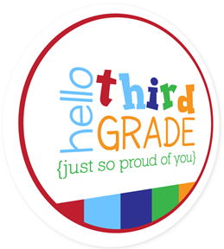

The foundation of our Morning Meetings most days is focus on character and building skills that help us to be successful as both scholars and friends. We take time regularly to build one another up in class by what we say and how we interact.

At our Citizens & Scholars Assemblies we recognized students who have stood out as examples of our monthly traits. This month our focus is on being EFFECTIVE COMMUNICATORS [Clearly conveying thoughts, questions, solutions, and ideas in multiple ways, including verbally, written, and digitally.]. We easily selected Avery E. and William V, to represent us.

**May your family’s holiday season be wrapped up with good cheer and your home be filled with love and laughter throughout the New Year!**

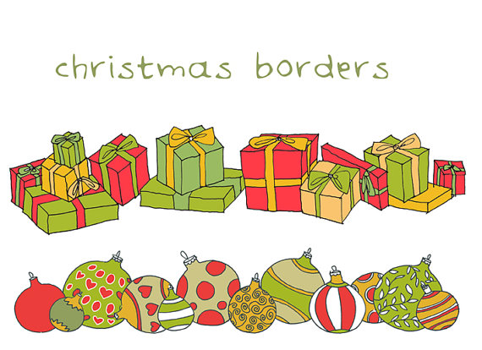

Winter break means a well-deserved reprieve (for students and parents alike!) from homework and daily obligations.

I encourage families to have a great time - without letting school skills like reading, writing, and math slide entirely during winter vacation. Here are some of my favorite family-friendly activities to build memories while keeping skills sharp:

**Read!** Whether your child is in the mood for holiday stories or the newest installment from a favorite series, this break provides the perfect opportunity to read for fun.

**Make the most of travel time.** Turn drives into opportunities to practice letters and numbers. You can look for license plates from different states, try to find the alphabet on the license plates, or count the number of red (or white or green) cars you see. Flights can include downloaded books, word finds, or Sudoku.

**Build something!** Whatever you use — clay, paper, Legos, wooden blocks —building is a great way for a child to stretch his/her imagination and think creatively.

**Have a family game night.** Chances are many of your family's favorite board and card games reinforce skills such as counting, reading, and drawing. Gather the group to play games you usually don't have time for on school nights.

**Cook up a scrumptious lesson.** Invite your child into the kitchen to help you whip up a special dish — from Christmas cookies to potato pancakes. Recipes provide great practice with math and following directions.

**Write thank-you notes.** Taking time to write notes of appreciation to gift-givers teaches gratitude and helps polish writing and spelling skills.

**Celebrate the season of giving.** Involve your children in focusing on others. Ideas include chores at home (of course!), lending a hand to elderly neighbors, sorting or packing food at Loaves & Fishes [kids 6-12 can volunteer if accompanied by an adult - loavesandfishes.org], sort clothing and help out in the production area of the Crisis Assistance store [crisisassistance.org], volunteer at Bright Blessings in Matthews [a non-profit that provides services for homeless children through its Bless-A-Baby and Bless-A-Birthday programs - BrightBlessingsUSA.org]

**And lastly, go digital.** Shortly after we return from break students will take their mid-year MAP tests. The best way to prepare for these is to spend time on Edgenuity. This program can be accessed through the “Websites for Students” page on our class web site.

“Children see magic because they look for it.”

**- Christopher Moore (American Writer)**

## Tips to Keep Skills Sharp While Away